**B9MG116- International Management**

**Module/Subject Title: International Management**

**Lecturer Name: Enda Murphy**

**Assignment Title: Country Analysis- New Zealand**

**Students Name & Numbers:**

**Bhushan Chaudhari (10517074)**

**Chetan Padme (10393059)**

**Pavan Pardeshi (10380700)**

**Nirav Vichare (10517867)**

**Word count : 4080 (Under 4000+10 %)**

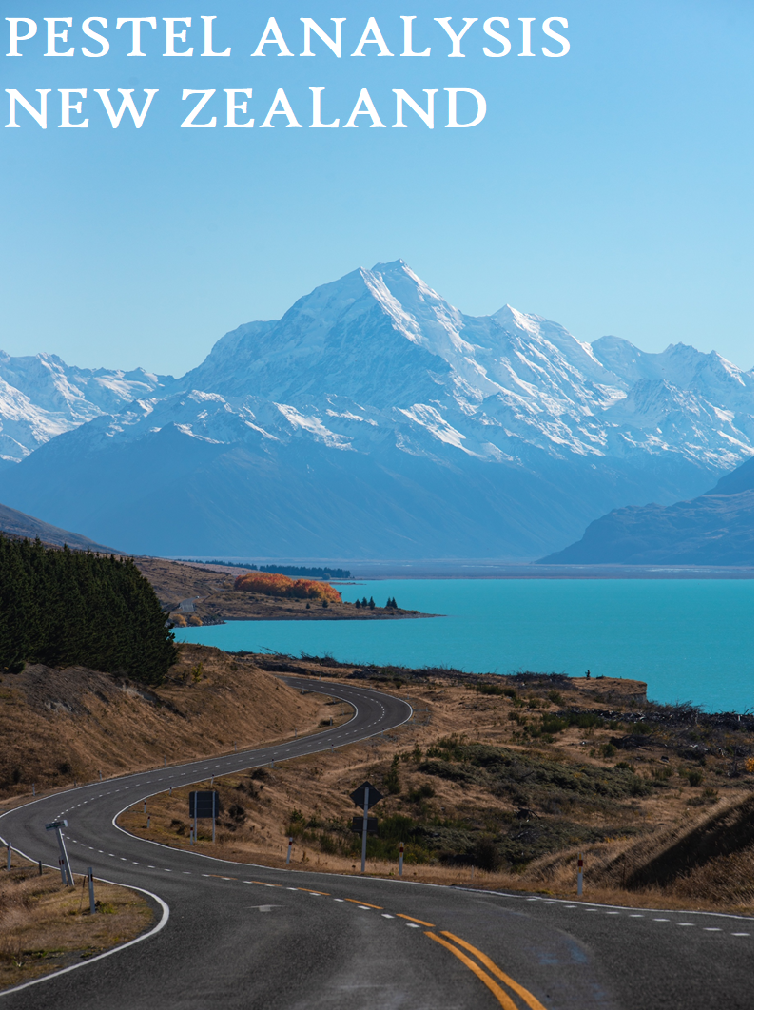

INDEX

EXECUTIVE SUMMARY 5

Fact Sheet 7

1. POLITICAL FACTORS 9

1.1. POLITICAL STABILITY 9

1.2. SEVEN STRATEGIC GOALS 9

1.3. FOREIGN POLICIES 10

2. ECONOMIC FACTORS 10

2.1. GDP 11

2.2. GDP ANNUAL GROWTH RATE 11

2.3. INFLATION RATE 11

2.4. UNEMPLOYMENT RATE 12

2.5. CONSUMER SPENDING 12

2.6. GOVERNMENT SPENDING 13

3. SOCIAL CULTURE 14

3.1. HEALTH CONSCIOUSNESS 14

3.2. EDUCATION LEVEL 14

3.3. IMPORTS & EXPORTS 14

3.3.1. IMPORT 15

3.3.2. EXPORT 15

3.4. WORK AND RETIREMENTS 15

3.5. LIFESTYLE 15

3.6. RELIGION 16

3.7. ECOLOGICAL PRODUCTS 16

3.8. MIGRATION RATE 17

3.9. LIFE EXPECTANCY 17

3.10. GENDER RATIO 18

3.11. AVERAGE DISPOSABLE INCOME LEVEL 18

4. TECHNOLOGICAL ENVIRONMENT 19

4.1. CLEAN TECHNOLOGY 19

4.2. REPLACED ENERGY 19

4.3. WIND POWER 20

4.4. TELECOMMUNICATION AND INTERNET CONNECTIVITY 20

4.5. TRANSPORT 21

**4.5.1.** **AIR** 22

**4.5.2.** **ROAD** 22

**4.5.3.** **RAILWAYS** 22

4.6. SPENDING ON RESEARCH & DEVELOPMENT 22

5. ENVIRONMENTAL 23

5.1. WEATHER 23

5.2. LAWS REGULATING ENVIRONMENTAL POLLUTION: 23

5.3. AIR AND WATER POLLUTION: 24

**5.3.1.** **AIR POLLUTION** 24

**5.3.2.** **WATER POLLUTION** 24

5.4. RECYCLING 24

6. LEGAL 25

6.1. FISCAL AND MONETARY POLICY 25

6.2. TAX SYSTEM 26

6.3. COMPETITION (ANTITRUST) LAW: 26

6.4. COPYRIGHT, TRADEMARKS OF INTELLECTUAL PROPERTY. 26

**6.4.1.** **COPYRIGHT:** 26

**6.4.2.** **TRADEMARKS:** 26

7. MARKET ENTRY ROUTES 27

7.1. MERGER AND ACQUISITION 27

7.2. FRANCHISING 28

7.3. MARKET CONSIDERATIONS 28

8. CULTURAL CHALLENGES: MANAGING EMPLOYEES IN THE MARKET 29

LANGUAGE 29

8.1. BUSINESS STYLE 30

8.2. VIEW ON ENGELHART - WELZEL MODEL 31

8.3. CULTURAL DIMENSIONS 31

8.4. CULTURAL TYPES: THE LEWIS MODEL 32

8.5. LEADERSHIP STYLE 32

8.6. OTHER CHALLENGES FACED BY MIGRANTS 33

**8.6.1.** **Housing and accommodation** 33

FIGURES 34

TABLES 34

BIBLIOGRAPHY 34

# EXECUTIVE SUMMARY

**Market Entry Consideration:**

Based on the past study, the basic entry strategy recommended for business development based on vertical is as follows:

* Merger and acquisition is the most favourable way of foreign IT firms since there is a lot of customer base as well as a skilled workforce to back that up with the small businesses which are already there and looking for expansion.
* Whereas, a most suitable option for administration & support, retail Trade, construction & educational services companies is Franchising since most kiwis are having an entrepreneur mindset. Since it has worked in the past and to go for a greenfield project would be not suitable since it is a new market.
* However, for chemical & pharmaceutical companies it is better to go for greenfield project since there is a lot of demand as well as it is a good formula to maximize profit rather than sharing it by doing M&A, still for a target is particular product then most companies go for M&A.

**Cultural Challenges: Managing employees in the market.**

According to an overview of cultural challenges faced by employees in the market are as follows:

* A language barrier is the most common challenge faced by immigrants while different business styles may take some time to adjust employees.
* Taking Engelhart-Welzel model into consideration New Zealand is in the middle right side and Lewis model shows that New Zealand comes in a linear-active group.
* Housing and accommodation is also a critical challenge for immigrants.

# Fact Sheet

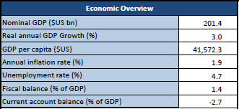 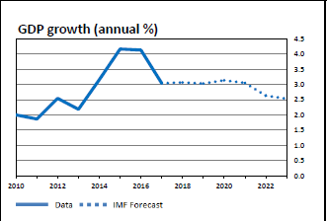 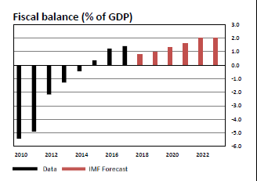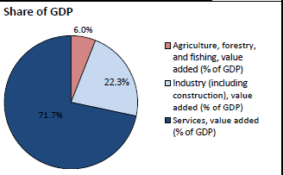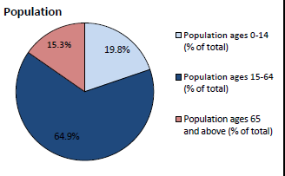 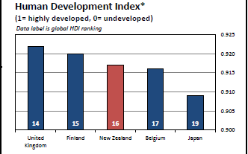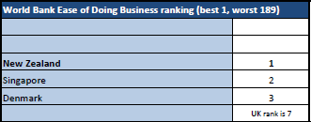 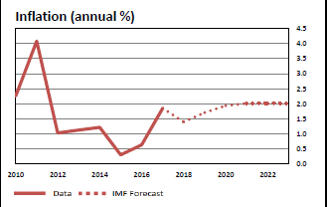 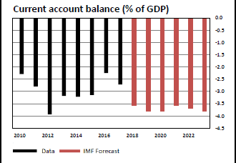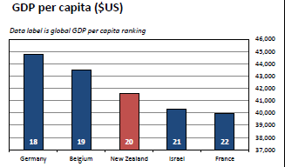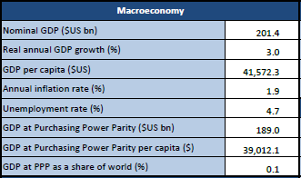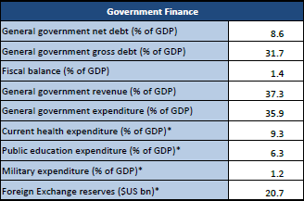 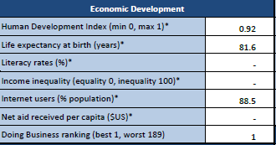 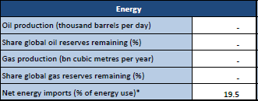C:\Users\Nirav\Pictures\New Zealand\Capture 16.PNG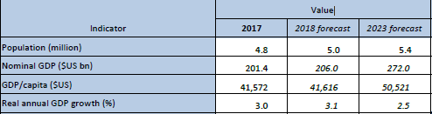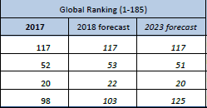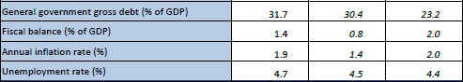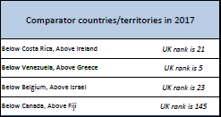

# POLITICAL FACTORS

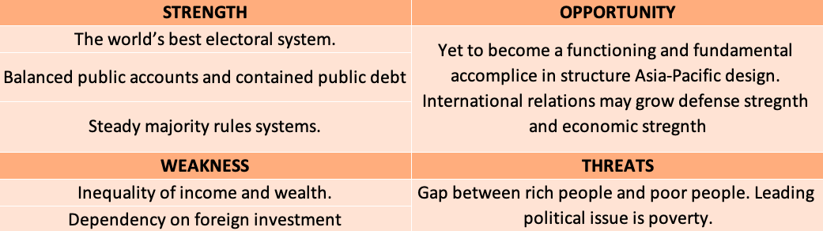

## POLITICAL STABILITY

New Zealand is one of the world's most steady majority rules systems.

In a brutal world, New Zealand demonstrates the world as a healthy performer in various fields like social quality, economics as well as politics. In the world of competition new Zealand is a very steady nation that it is the third most peaceful nation according to the Fund for Peace 2016 Fragile States Index.

Due to democracy and people rule there is ample of diversity and representativeness in the parliament which involves public participation in political process (New Zealand Immigration, n.d.).

## SEVEN STRATEGIC GOALS

Figure Seven Strategies Goal - (New Zealand Foreign Affair And Trade, n.d.)

There are Seven Strategies planned by New Zealand Ministry to achieve goals which are planned for the next 10 years’ timeframe to maintain relations internationally.

* Strengthening, protecting using international rules.
* Sustainable growth in economic returns and resilience from the trade, investments and connecting with the international markets.
* Insert New Zealand as a functioning and fundamental accomplice in structure Asia-Pacific design in the help of local dependability and monetary joining.
* Promoting growing, steady and resilient Pacific where people are safeguarded.
* New Zealand impacts resources challenges and solutions to global warming promoting sustainability.
* Due to international connections or relations, it has built a strong safeguarding environment.
* Goals are being achieved by maintaining international relations (New Zealand Foreign Affair And Trade, n.d.).

## FOREIGN POLICIES

The current year's Strategic Intentions mirrors the Ministry's new Strategic Framework. New Zealand follows the same framework for 2018 which they had for 2017, some are adjusted to state the Ministry values clearly to New Zealanders. Some of the values are New Zealanders' well-being which is in terms of Kaitiakitanga, influence, prosperity and security.

The future scope in the foreign policy is to set goals for the next or upcoming ten years. The foreign policies also want the outcomes and results as per the goals that are appropriate or precise and also in the given time frame.

These goals set in foreign policies are set to meet the international standards and to maintain international relationships. The foreign policies also clearly distinguish between Priority Deliverables and Ministry's enduring work which are for the next four years.

# ECONOMIC FACTORS

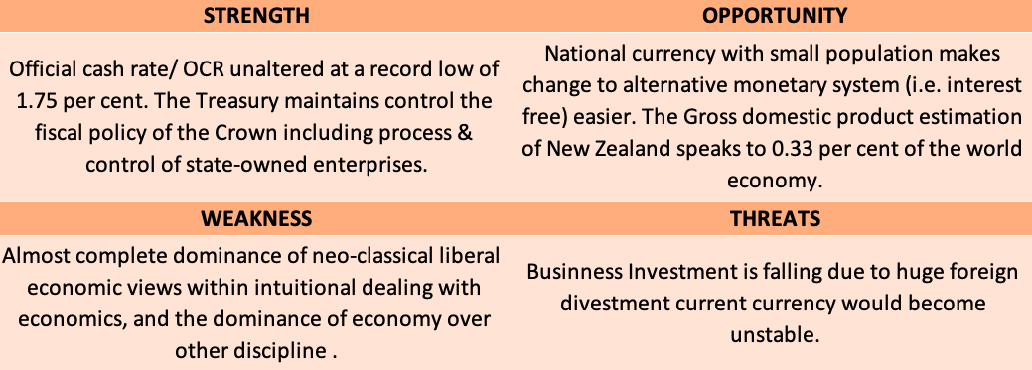

## GDP

GDP of New Zealand merited unsurpassed high of 205.85 USD Billion in the year 2017 (Trading Economics, n.d.). the historic trend shows that the GDP of New Zealand is gradually increasing.

**GDP
**

Graph 1 Historic Data Of The Gross Domestic Product - (Trading Economics, n.d.)

As indicated by Trading Economics’ econometric models, the New Zealand GDP is anticipated to drift around 250.00 USD Billion in 2020 (Trading Economics, n.d.).

## GDP ANNUAL GROWTH RATE

In the previous period the GDP growth rate was 3.2 per cent But in the third quarter of 2018 it has descended down to 2.6 percent below market expectation that is 2.8 percent. This is the lowest development seen in since final quarter of 2013 (Trading Economics, n.d.).

Graph 2 Historic Data Of The GDP Annual Growth Rate - (Trading Economics, n.d.)

As indicated by Trading Economics’ econometric models, the New Zealand GDP Annual Growth Rate is anticipated to drift around 2.60 per cent in 2020 (Trading Economics, n.d.) (Trading Economics, n.d.).

## INFLATION RATE

Increase of 1.9 percent in consumer Prices is seen in the final quarter of 2018 which is almost same as the one seen in the third quarter and significantly above the expectation that is 1.8 percent .Expansion remained at its most abnormal amount in five quarters (Trading Economics, n.d.).

As indicated by Trading Economics’ econometric models, The New Zealand Inflation Rate is anticipated to incline around 2.10 per cent in 2020 (Trading Economics, n.d.).

Graph 3 Historic Data of the Inflation rate - (Trading Economics, n.d.)

Increase from 1024 to 1025 in index point is seen in the final quarter of 2018 i.e., The Consumer Price Index CPI in New Zealand ascended by 0.097 per cent (Trading Economics, n.d.).

## UNEMPLOYMENT RATE

At the end of 2018 the increase of 4.3 per cent has been seen in the unemployment rate while the expected was 4.0 percent (Trading Economics, n.d.).

Graph 4 Historic Data Of The Unemployment Rate - (Trading Economics, n.d.)

As indicated by Trading Economics’ econometric models, the New Zealand Unemployment Rate is anticipated to drift around 2.40 per cent in 2020 (Trading Economics, n.d.).

## CONSUMER SPENDING

According to the third quarter of 2018, expenditure of consumers expanded from 38101 NZD Million to 38478 NZD Million (Trading Economics, n.d.).

Graph 5 Historic Data Of The Consumer Spending - (Trading Economics, n.d.)

As indicated by Trading Economics’ econometric models, Expected Consumer Spending at the end of 2020 would be 40594.00 NZD Million (Trading Economics, n.d.).

## GOVERNMENT SPENDING

According to the third quarter of 2018, Government expenditure dropped from 11419 NZD Million to 11294 NZD Million (Trading Economics, n.d.).

Graph 6 Historic Data Of The Government Spending - (Trading Economics, n.d.)

As indicated by Trading Economics’ econometric models, Expected Government expenditure at the end of 2020 would be 12390.00 NZD Million (Trading Economics, n.d.).

# SOCIAL CULTURE

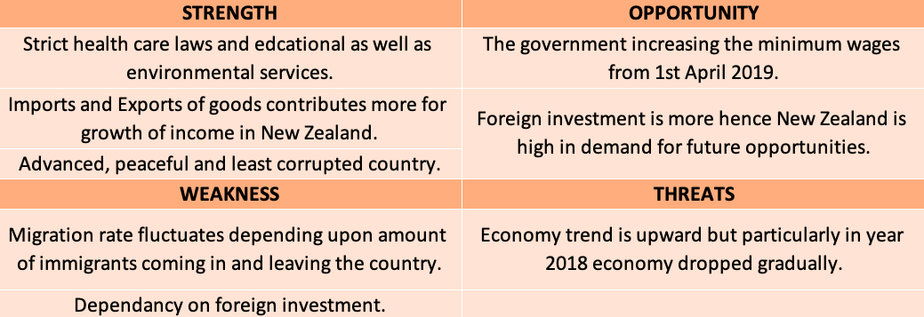

## HEALTH CONSCIOUSNESS

Approaches to preventing and manage smoking, hazardous drinking, obesity, mental health, oral health.

The government increased the annual tobacco tax of 10%.

The government is developing self-help tools such as Alcohol Drug Helpline which addresses their alcohol issues by primary health care as well as specialist services.

In 2016-17, around 51000 Green Prescriptions (GRx) were issued to the patients, which is a script from doctors to make healthy lifestyle changes. It's designed to increase physical activities as well as to improve nutrition in children and young aged people (Ministry of Transport, 2019).

## EDUCATION LEVEL

New Zealand’s education system is divided into three levels; i.e. Early childhood education (ECE) (Children aged 3 – 5 years), primary & secondary education (Aged 5 to 17) and Further studies (EDUCATION.govt.nz, 2019).

## IMPORTS & EXPORTS

New Zealand's largest imports are vehicles and aircraft, followed by machinery including computers and equipment, petroleum, electronics, textiles, and plastics.

According to Trading Economics’ econometric models, Expected figures for Exports & Import in 2020 are 5100.00 & 5400.00 NZD Million respectively.

## IMPORT

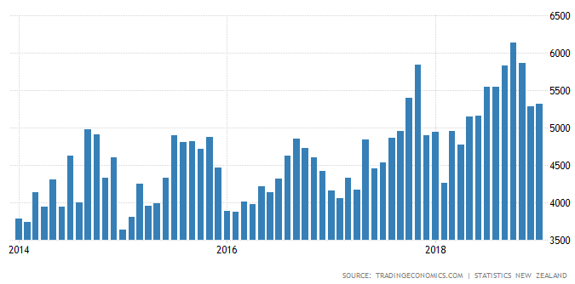

Graph 8 Historical Data of Import - (Trading Economics, n.d.)

## EXPORT

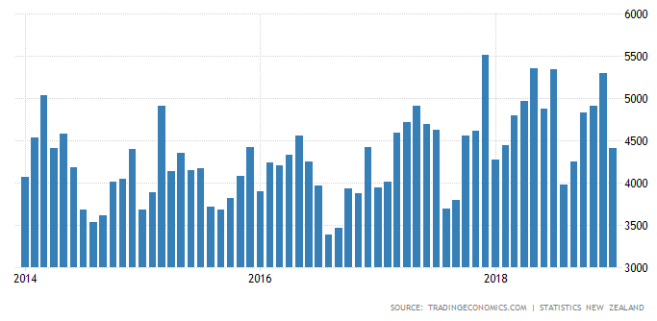

Graph 9 Historical Data of Export - (Trading Economics, n.d.)

## WORK AND RETIREMENTS

The total work time is 40 hours per week excluding overtime. People under age 16 cannot work between 10 pm and 6 am on any day. However, they can work during weekdays or between 6 am and 10 pm on weekends as well as during school holidays. The government announced that the minimum wages rate was $13.20 which will increase to $14.16 and $17.70 an hour. (Ministry of Business, Innovation & Employment, 2019) (Employment New Zealand, 2019)

There is no exact retirement age in New Zealand other than some exceptions such as an actor who needs to be a certain age for a role, gardeners, judges and coroners. (New Zealand Now, 2018)

## LIFESTYLE

New Zealand is consistently rating among the world’s most peaceful and least corrupt countries. Communities are safer, greater personal freedom and more peace of mind because of strict border controls and low crime rates.

According to the list of safest countries to live in, New Zealand stood fourth in global peace index 2017.

New Zealand has advanced cities where life is less pressured.

In 2016, Auckland ranked third in Quality of Living survey conducted by global HR consultants Mercer.

## RELIGION

There are different religious people are living in New Zealand. (Religion Facts, 2016)

Figure 3 Percentage of Population on the basis of Religion.- (Religion Facts, 2016)

## ECOLOGICAL PRODUCTS

In New Zealand, most companies believe in giving the ethical product and ethical services in order to have ethical & growing healthy economy. Some of them are as follows:

Green Elephant: - Provides skin care and clothes cleaning products.

Pouch Products: - Provides hand-crafted reusable eco-friendly shopping pouches.

Trees Please! : - Manufacturer of tree gifts.

SKYCITY Entertainment group

Sustainability Trust: - Provides energy saving products and services for homeowners.

(Goodonyou.org.nz, 2019)

## MIGRATION RATE

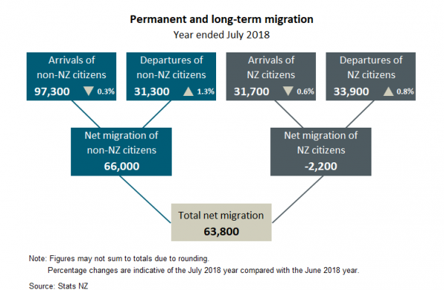

Graph 10 Historic Data of Migration - (stats.govt.nz, 2018)

Graph 11 Historic data Of Population Growth Rate - (figure.nz, 2019)

## LIFE EXPECTANCY

The life expectancy of New Zealand's people at the time of birth in the year 2015 was 81.46 years in which life expectancy of a male is 79.73 years and female are 83.27 years. (canstar.co.nz, 2018)

## GENDER RATIO

The male to female ratio of New Zealand for different age structure as per the New Zealand demographic profile 2018 are as follows:

Graph 12 Gender Ratio - (New Zealand Demographics Profile 2018, 2018)

## AVERAGE DISPOSABLE INCOME LEVEL

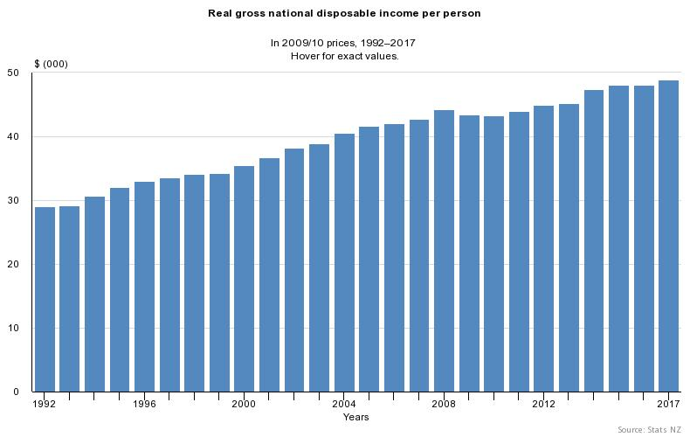

Graph 13 Average Disposable Income Level (NZ Social Indicator, 2017)

From the year 1992, income growth is increased from $29.089 to $48.929 per person. It shows the available amount of goods and services in New Zealand (NZ Social Indicator, 2017).

# TECHNOLOGICAL ENVIRONMENT

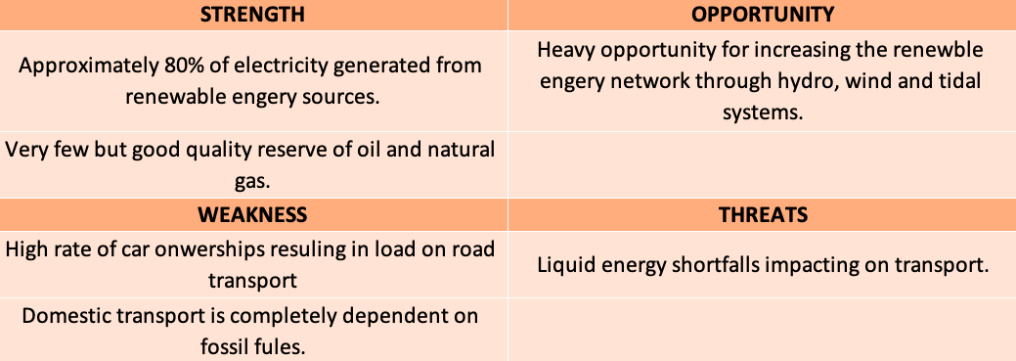

## CLEAN TECHNOLOGY

New Zealand's pure advantage business group published in their recent report that, New Zealand invested $250 billion a year in the development of clean technology which is more than total amount invested by the world in fossil-fuel and nuclear power (Kenworthy, 2013).

New Zealand produces almost 80% of electricity from renewable energy resources among which 60% is generated by hydro-power (Jones, 2017).

Figure 1 Clean technology resource Solar Panels - (Andrew, May 2018)

* 1. REPLACED ENERGY

New Zealand is having a solid history in replacing renewable energy with a spearheading enthusiasm for geothermal power and many years of skill in hydro generation. New Zealand is also developing energy from waves and tidal flows.

New Zealand set a goal of 100% renewable energy by 2035 (Bloch, 2017).

Figure 80 per cent of our electricity comes from renewable sources - (Andrew, May 2018)

## WIND POWER

Wind power is the major source of the rapid growth of states electricity. Sources have been established in the late 1990s and now in 2018, there are 19 wind farms, which results in a capacity of 690 MW of electricity generation (Energy Efficiency and Conservation Authority, 2018).

Figure Wind Farms in New Zealand - (Anon., n.d.)

## TELECOMMUNICATION AND INTERNET CONNECTIVITY

New Zealand has a large telecommunication sector while they establish their own setup in 1987 but sold in 1990. Spark New Zealand, 2degrees and Vodafone NZ are the three main telecom providers in New Zealand nowadays. For the internet, there are almost 36 ISP's providing a connection to almost 3.8 million (Teara, n.d.).

Figure Communication system in houses - (Stats, 2015)

Figure Telecommunication Stats - (Stats, 2015)

## TRANSPORT

Figure Travel to Work transport data - (Stats, 2015)

### **AIR**

Auckland is the largest and busiest international airport in New Zealand. International air services are very important for New Zealand's economy as almost all tourists coming into the country are by air transport and 14% of export is carried by air transport services (Minisrty of Transport, 2018).

### **ROAD**

New Zealand has in total 11,000km state highway in which 5981.3km and 4924.4km are in north island and south island respectively. While local roads are of 83000km i.e. 17,298.3km urban and 65,600.7km rural (NZ transport agency, n.d.).

### **RAILWAYS**

The most effective, safe and reliable mode of transport in New Zealand is railways. Almost 15% of goods and heavy equipment are carried through the rail. Rail is reducing loads of roads due to which ministry has short and medium-term goals to create proper governance, institutional, funding and appropriate structure for rail which will be resulting in contribution to the transport system (Ministry of Transport, 2019).

## SPENDING ON RESEARCH & DEVELOPMENT

Figure 8. Expenditure on R&D (PUTT, October 2018)

# ENVIRONMENTAL

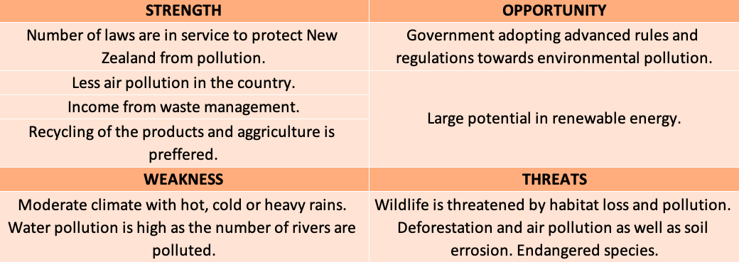

## WEATHER

The average temperature in New Zealand is mild and moderately high rainfall as well as 2000 hours of sunshine during the year. However, most snow in New Zealand falls in mountains area. There are four seasons in New Zealand which are spring, summer, autumn/fall, winter.

Average Temperatures as per the seasons (newzealand, n.d.)

## LAWS REGULATING ENVIRONMENTAL POLLUTION:

According to the OECD Review 1981, three types of central government agencies & an environmental management role are identified by the government.

Advisory Bodies and Administrative Agencies who handles some aspects of environmental policies.

Government Departments and Administrative Agencies, who manage and develop the sector of the economy.

Government Departments and Administrative Agencies, who manage and develop the natural resources sector which includes pre-determination of the framework in environmental policies (Ministry for the Environment, 1997).

## AIR AND WATER POLLUTION:

### **AIR POLLUTION**

The report shows that the use of wood and coal during winter continues to cause an issue of human-generated poor air quality in some places in New Zealand. On the other hand, the report also shows that vehicle emissions are also a leading cause of poor air quality.

Particles in the air cause short breathing and coughing problems which leads to asthma and some more serious issues. (stats.nz, 2018).

### **WATER POLLUTION**

According to the records of OECD, 75% of the water is used for irrigation. In some regions, the water quality continues to deteriorate due to the pollution from agriculture and urban areas in which nutrients (Nitrogen and Phosphorus), sediments and pathogens are the fatal pollutants.

The Waikato is one of the most polluted rivers in New Zealand. (OECD, 2017).

## RECYCLING

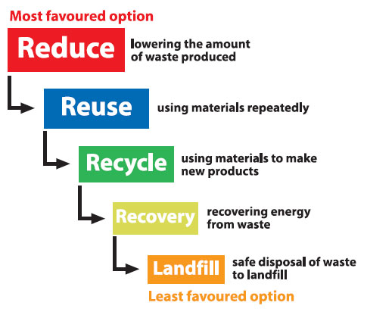

Figure 9 Philosophy of Recycling - (Marlborough District Council, 2019)

The Waste Minimisation Act 2008 encourages waste management in a proper manner to decrease the adverse effect on the environment due to waste and provide better environment to the people of New Zealand (Ministry For the environment, 2018).

# LEGAL

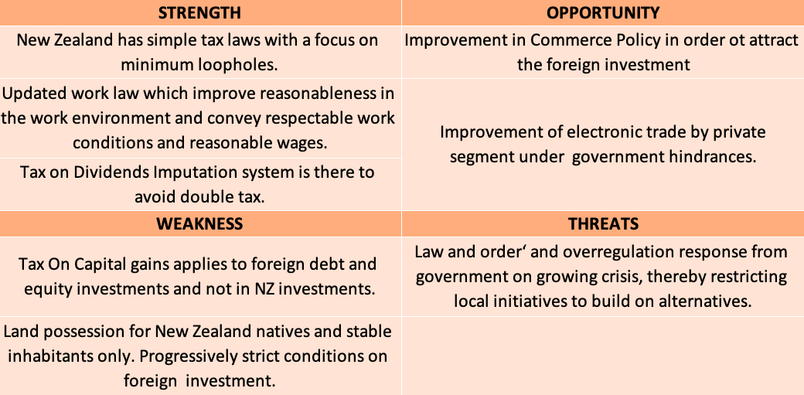

## FISCAL AND MONETARY POLICY

Because of the joint constitution of the New Zealand Treasury and Reserve Bank, Tax revenue and government spending are two main fiscal levers set by the government (Reserve Bank Of New Zealand).

The Reserve Bank controls the OCR and saves the necessities of banks - the monetary policy. The monetary policy incorporates moves made by the New Zealand Reserve Bank (RBNZ) to influence interest rates. The RBNZ additionally impacts cash supply, trade rates, monetary movement, employment, and expansion through this mechanism to meet its price stability objectives while avoiding undue economic and exchange rate volatility (New Zealand Institute Of Economic Research, n.d.).

Figure The Monetary Policy Process - (Reserve Bank Of New Zealand)

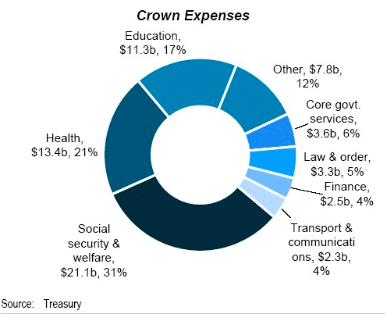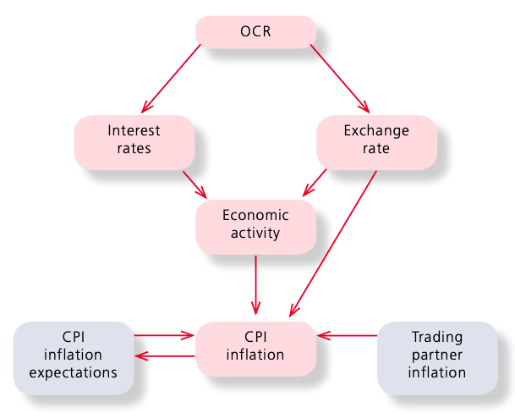

Figure Crown Expense - (New Zealand Institute Of Economic Research, n.d.)

## TAX SYSTEM

New Zealand's moves vary from numerous nations where Governments are boosting taxes to meet the growing budget deficit. It has the significant attractions of consistency, decency and straightforwardness (New zealand wind energy association, n.d.). Savings, as well as distributions, are tax-free as at source tax to be +paid at normal income levels (New zealand wind energy association, n.d.)

Graph Tax Structure - (Immigration, n.d.)

## COMPETITION (ANTITRUST) LAW:

In New Zealand, Commerce Commission sets and enforces competition law as per commerce Act, 1986. New Zealand is simple, straightforwardness, lenient as compared to other strict countries (New Zealand Trade And Enterprise, n.d.).

In 2017, Commission has chosen a few critical merger applications and attempted examinations and support work to secure and empower consumers. aims to achieve wonders in competitive and regulated markets for the bright future of New Zealanders (Berry, 19 March 2018).

## COPYRIGHT, TRADEMARKS OF INTELLECTUAL PROPERTY.

### **COPYRIGHT:**

Under the Copyright Act 1994, there is no need to enlist copyright in New Zealand as copyright protection appears naturally when a unique work is made and fixed. Unique works made in nations who are involved with the Exchange Related Parts of Protected innovation Rights assertion are additionally bound in New Zealand under this Understanding (New Zealand Intellectual Property Rights, n.d.).

### **TRADEMARKS:**

In New Zealand, a trademark owner seeking protection of their trademark should initially register the trademark with the Intellectual Property Office of New Zealand (IPONZ). The security that is obtainable to trademark owners in New Zealand sets out the Trade Marks Act 2002 (New Zealand Intellectual Property Rights, n.d.).

# MARKET ENTRY ROUTES

New Zealand is a well-developed country. In which, Spark is a telecom company started on 1st April 1987. The organization is well known as Telecom New Zealand and now it's well known as SPARK. In the entire Pacific and Oceanic region, the first country to establish internet connection was New Zealand. In 1987, Telecom (Spark) launched New Zealand's first mobile phone network. In 1990, calling cards, 0800 and 0900 numbers, voice mails and telebanking were introduced as well as toll calls become cheaper and more launched its first ISP.



During the year of 2011, telecom was structured in such way it had two different subsidiaries Telecom which dealt with retailer and mobile voice service and Chorus which was discount centred administrator of fixed-line system and used to pitch access to retailer, at that time spark was one of their retailer. After this, on 8 August 2014, Telecom introduced broadband service, entertainment media as well as cloud computing which then turned the companies rebranding to Spark New Zealand. (Spark NZ, 2019)

## MERGER AND ACQUISITION

In 2017, merger and acquisition fever achieved a new level in New Zealand with big deals in market companies. Some of them are as follows:

Apple brought wireless charging technology from the developer PowerbyProxi in October. The aim was to develop the technology as the PowerbyProxi which designed and implemented technology of wireless charging which was dense and efficient. TPT Group acquired an Auckland based IT company named as Sentinel Technologies as the Sentinel Technology delivers a wide range of IT services which includes cloud computing, back-ups, cybersecurity and advisory services.



Spark purchases all shares in Digital Island in November which is a New Zealand based business telecom provider.

Portlock Group which is an operational and IP network-based security management solution and consultation provider acquired an IT company named as Comsmart. The basic strategy behind this was to expand the range of business and service solutions capabilities.



Voyager which is an internet service provider bought a local company Conversant to use Conversant’s voice technology platform and VoIP solutions (Reseller.co.nz, 2019).

## FRANCHISING

There are around 631 franchisors in New Zealand according to the survey in 2017. The graph shows that the percentage of franchise brands by sector.

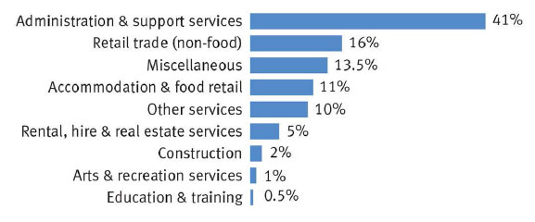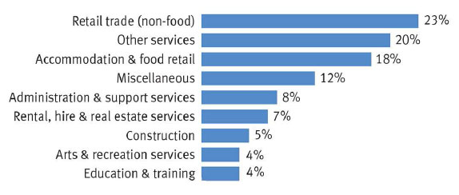

Fig. Franchise Brands Units by sector. Fig. Franchise Brands by sector.

In this, the Administration and support services are the categories which include brands with a large number of franchisees in New Zealand. However, the number of units has increased from 22,400 in the year 2012 to 37000 in the year 2017 (Franchise New Zealand, 2019).

## MARKET CONSIDERATIONS

From the statistics and the graphs, it has been seen that in New Zealand is rich with opportunities in the merger and acquisition because of most of the organizations finalised larger deals recently. The technology and food, as well as telecom, are the primary investment areas in New Zealand. Multinationals such as Apple, Spark, Fortlock Group maximises local partnership to increase business and provide innovative services to the customers in New Zealand.

In conclusion, the basic recommended entry strategy for business development is M&A as well as Franchisees in New Zealand.

In Growing Technological environment of New Zealand, M&A, franchisees as well as e-commerce market is growing and is of interest among investors.

# CULTURAL CHALLENGES: MANAGING EMPLOYEES IN THE MARKET

## LANGUAGE

In New Zealand, bosses regularly talk in a less immediate way, which can make the directions seem like requests not like demand.

The work culture in New Zealand is not too much formal. The employee can make use of a lot of informal language at work which also includes swearing as well as slang words. This is very difficult for those employees whose English may be very formal and migrants who use to speak very fluent and formal English. It is also possible that few may get offended by such informal languages.

It very well may be trouble for your new worker who is trying to adjust with correspondence styles in an alternate language and culture (Government, 2019).

Figure Employment Rates of Migrants by Immigration Category and English Proficiency - (The office of ethnic communities)

To fit effectively into a work environment here person should know about those distinctions and prepared to acclimate to the New Zealand method for working. ‘Can do' attitude of New Zealanders helps them to be well-liked employees in any organization over any part of the world (New Zealand Now, 2019).

Figure Work Culture (Contributing ideas and feedback) - (New Zealand Now, 2019)

## BUSINESS STYLE

The main reason which impacts on the way of working is that sizes of organizations are very small. A large number of organizations have under 14 employees in their organisation. The large businesses in New Zealand are also small by international standards (New Zealand Now, 2019).

Almost 40% of economic output is carried out by the SME i.e. small to medium-sized Enterprises having less than 20 employees (New Zealand Now, 2019).

Small scale business has its own benefits:

* Less organizational layers
* Fewer specialization requirements
* Possible to get a jump start
* Independent working
* Smaller teams great teamwork (New Zealand Now, 2019)

Figure New Zealand's firms' comparison - (New Zealand Now, 2019)

## VIEW ON ENGELHART - WELZEL MODEL

The given image is the Ingelhart-Welzel model.

In which we can say that New Zealand comes in the region of English-speaking nations neighbouring Canada and Australia. New Zealand stands in the middle right side of the graph indicating the highest self-expression values. It also shows that the standard of living and development of industrialisation in better than other countries (Ambrosino, 2014).

Figure Ingelhart-Welzel model - (Ambrosino, 2014)

## CULTURAL DIMENSIONS

6-D Model gives a decent outline with the help of profound drivers indicating way of life culture in accordance with the other communities in the world (Hofstede insights, n.d.).

Figure Hofstede insights - (Hofstede insights, n.d.)

The graph illustrates that low scorers are in the society are those who have the caring nature as well as quality of life. The same graph states that how the citizens of the country believe in the past experiences and results to solve the present and the future problems or challenges. The given two existential goals are prioritised separately (Hofstede insights, n.d.).

## CULTURAL TYPES: THE LEWIS MODEL

Figure The Lewis Model - (cuco_admin, 2015)

According to Lewis model linear-active group can be identified easily although New Zealand is not listed in the above figure the linear-active group consists of English-speaking nations like Britain, North America, Australia and New Zealand. Scandinavia and other German countries are also coming under this group (cuco_admin, 2015).

## LEADERSHIP STYLE

Six main leadership styles have been observed over a study of 3 years by the study of 3000 business leaders. This is done by scientist Daniel Goleman.

The leadership styles are as follows:

Authoritative leaders: thinking of future and depending on peoples for getting results, innovative thinking.

Pacesetting leaders: Quick responsive and forcing employees for better results and achieve goals

Affiliative leaders: strong in trust and relationship building, good co-operation within teams

Democratic leaders: calm, deep thinking, problem-solving is done by consensus, always motivates everyone

Coaching leaders: supports members in every aspect

Coercive leaders: decision making without teams, ability to take charge (Business government New Zealand, n.d.).

Figure Leadership Visualization - (Globe, n.d.)

## OTHER CHALLENGES FACED BY MIGRANTS

### **Housing and accommodation**

Due to a large number of migrants in New Zealand, it is getting very difficult to get accommodation and cost of living is also too high.

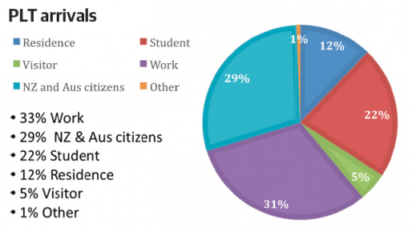

Figure 19 Percentile immigrants in New Zealand - (Jason Krupp, 2017)

# FIGURES

Figure 2 Seven Strategies Goal - (New Zealand Foreign Affair And Trade, n.d.) 7

Figure 3 Percentage of Population on the basis of Religion.- (Religion Facts, 2016) 14

Figure 4 80 per cent of our electricity comes from renewable sources - (Andrew, May 2018) 18

Figure 5 Wind Farms in New Zealand - (Anon., n.d.) 18

Figure 6 Communication system in houses - (Stats, 2015) 19

Figure 7 Telecommunication Stats - (Stats, 2015) 19

Figure 8 Travel to Work transport data - (Stats, 2015) 19

Figure 9 Philosophy of Recycling - (Marlborough District Council, 2019) 22

Figure 10 The Monetary Policy Process - (Reserve Bank Of New Zealand) 23

Figure 11 Crown Expense - (New Zealand Institute Of Economic Research, n.d.) 24

Figure 12 Employment Rates of Migrants by Immigration Category and English Proficiency - (The office of ethnic communities) 28

Figure 13 Work Culture (Contributing ideas and feedback) - (New Zealand Now, 2019) 29

Figure 14 New Zealand's firms' comparison - (New Zealand Now, 2019) 29

Figure 15 Ingelhart-Welzel model - (Ambrosino, 2014) 30

Figure 16 Hofstede insights - (Hofstede insights, n.d.) 30

Figure 17 The Lewis Model - (cuco_admin, 2015) 31

Figure 18 Leadership Visualization - (Globe, n.d.) 32

Figure 19 Percentile immigrants in New Zealand - (Jason Krupp, 2017) 32

# TABLES

Graph 1 Historic Data Of The Gross Domestic Product - (Trading Economics, n.d.) 9

Graph 2 Historic Data Of The GDP Annual Growth Rate - (Trading Economics, n.d.) 9

Graph 3 Historic Data of the Inflation rate - (Trading Economics, n.d.) 10

Graph 4 Historic Data Of The Unemployment Rate - (Trading Economics, n.d.) 10

Graph 5 Historic Data Of The Consumer Spending - (Trading Economics, n.d.) 11

Graph 6 Historic Data Of The Government Spending - (Trading Economics, n.d.) 11

Graph 8 Historical Data of Import - (Trading Economics, n.d.) 13

Graph 9 Historical Data of Export - (Trading Economics, n.d.) 13

Graph 10 Historic Data of Migration - (stats.govt.nz, 2018) 15

Graph 11 Historic data Of Population Growth Rate - (figure.nz, 2019) 15

Graph 12 Gender Ratio - (New Zealand Demographics Profile 2018, 2018) 16

Graph 13 Average Disposable Income Level (NZ Social Indicator, 2017) 16

Graph 7 Tax Structure - (Immigration, n.d.) 25

# BIBLIOGRAPHY

Ambrosino, B. (2014). *vox*. Retrieved March 13, 2019, from https://www.vox.com/2014/12/29/7461009/culture-values-world-inglehart-welzel

Andrew, A. (May 2018). *Stuff*. Retrieved February 25, 2019, from https://www.stuff.co.nz/business/104012359/preparing-for-new-zealands-energy-revolution

Berry, M. (19 March 2018). *GCR*. Retrieved March 3, 2019, from https://globalcompetitionreview.com/insight/the-asia-pacific-antitrust-review-2018/1166739/new-zealand-commerce-commission

Bloch, M. (2017). *Solarquotes blog*. Retrieved February 28, 2019, from https://www.solarquotes.com.au/blog/nz-renewable-energy-mb0264/

*Business government New Zealand*. (n.d.). Retrieved Mrach 12, 2019, from https://www.business.govt.nz/business-performance/management-and-leadership/leadership-styles-and-when-to-use-them/

*canstar.co.nz*. (2018, February 13). Retrieved from https://www.canstar.co.nz/life-insurance/new-zealand-life-expectancy/

cuco_admin. (2015). *crossculture*. Retrieved March 13, 2019, from https://www.crossculture.com/the-lewis-model-dimensions-of-behaviour/

*EDUCATION.govt.nz*. (2019, January 03). Retrieved from education.govt.nz: https://www.education.govt.nz/our-work/our-role-and-our-people/education-in-nz/

*Employment New Zealand*. (2019, March 15). Retrieved from https://www.employment.govt.nz/hours-and-wages/hours-of-work/

*Energy Efficiency and Conservation Authority*. (2018). Retrieved February 21, 2019, from https://www.eeca.govt.nz/energy-use-in-new-zealand/energy-strategy-and-policy/

*Energy Efficiency and Conservation Authority*. (2018). Retrieved March 1, 2019, from https://www.eeca.govt.nz/energy-use-in-new-zealand/renewable-energy-resources/wind/

*figure.nz*. (2019). Retrieved March 2, 2019, from figure.nz: https://figure.nz/chart/cnIf4aN5f1Xfe16y

*Franchise New Zealand*. (2019). Retrieved from https://franchise.co.nz/article/2576-2017-survey-confirms-nz-is-the-most-franchised-country-in-the-world?cat_id=12

*Globe*. (n.d.). Retrieved March 12, 2019, from https://globeproject.com/results/countries/NZL?menu=list

*Goodonyou.org.nz*. (2019). Retrieved from Good On You: http://goodonyou.org.nz/green-sustainable-ethical-products-services-in-new-zealand/

Government, N. Z. (2019). *New Zealand immigration*. Retrieved March 12, 2019, from https://www.immigration.govt.nz/employ-migrants/settle-migrant-staff/communication-and-culture

*Hofstede insights*. (n.d.). Retrieved March 13, 2019, from https://www.hofstede-insights.com/country/new-zealand/

Immigration, N. Z. (n.d.). *Newzealandnow*. Retrieved March 1, 2019, from https://www.newzealandnow.govt.nz/living-in-nz/money-tax/nz-tax-system

Jason Krupp, D. R. (2017). *The New Zealand Initiative*. Retrieved March 13, 2019, from https://nzinitiative.org.nz/reports-and-media/reports/the-new-new-zealanders/

Jones, B. (2017). *Futurism*. Retrieved February 22, 2019, from https://futurism.com/market-humanoid-robots-grow-ten-times-2023

Kenworthy, A. (2013). *nzherald.co.nz*. Retrieved February 22, 2019, from https://www.nzherald.co.nz/element-magazine/news/article.cfm?c_id=1503340&objectid=11132370

*Marlborough District Council*. (2019). Retrieved March 1, 2019, from https://www.marlborough.govt.nz/services/recycling-and-resource-recovery/kerbside-recycling-collection

*Minisrty of Transport*. (2018). Retrieved March 6, 2019, from https://www.transport.govt.nz/air/

*Ministry for the Environment*. (1997). Retrieved from The State of New Zealand's Environemet 1997: http://www.mfe.govt.nz/publications/environmental-reporting/state-new-zealand%E2%80%99s-environment-1997-chapter-four-environmental

*Ministry for the Environment*. (1997). Retrieved from http://www.mfe.govt.nz/publications/environmental-reporting/waste-generation-and-disposal-new-zealand

*Ministry For the environment*. (2018, July 3). Retrieved March 1, 2019, from http://www.mfe.govt.nz/waste/waste-strategy-and-legislation/waste-minimisation-act

*Ministry of Business, Innovation & Employment*. (2019). Retrieved from https://www.mbie.govt.nz/about/news/minimum-wage-going-up-to-17-70/

*Ministry Of Health*. (2019, January 17). Retrieved from Ministry Of Health: https://www.health.govt.nz/nz-health-statistics/national-collections-and-surveys/surveys/new-zealand-health-survey/improving-health-new-zealanders

*Ministry of Transport*. (2018). Retrieved March 5, 2019, from https://www.transport.govt.nz/

*Ministry of Transport*. (2019). Retrieved March 8, 2019, from https://www.transport.govt.nz/rail/

*Nation Energy Research Institute*. (n.d.). Retrieved February 20, 2019, from https://www.neri.org.nz/cleaner-longer-distance-transport

*New Zealand Demographics Profile 2018*. (2018, January 20). Retrieved March 3, 2019, from index mundi: https://www.indexmundi.com/new_zealand/demographics_profile.html

*New Zealand Foreign Affair And Trade*. (n.d.). Retrieved March 5, 2019, from https://www.mfat.govt.nz/en/about-us/our-strategic-direction/

*New Zealand Government*. (2018, June 12). Retrieved from Retirement Age: https://www.govt.nz/browse/work/retirement/retirement-age/

*New Zealand Immigration*. (n.d.). Retrieved March 4, 2019, from https://www.newzealandnow.govt.nz/investing-in-nz/stability-security

*New Zealand Institute Of Economic Research*. (n.d.). Retrieved February 25, 2019, from https://nzier.org.nz/about/economics-explained/fiscal-policy/

*New Zealand Intellectual Property Rights*. (n.d.). Retrieved March 4, 2019, from https://www.iponz.govt.nz/about-ip/copyright/legislation/

*New Zealand Now*. (2018). Retrieved March 5, 2019, from https://www.newzealandnow.govt.nz/live-in-new-zealand/getting-started/transport

*New Zealand Now*. (2019). Retrieved March 12, 2019, from https://www.newzealandnow.govt.nz/work-in-nz/nz-way-of-working

*New Zealand Trade And Enterprise*. (n.d.). Retrieved March 2, 2019, from https://www.nzte.govt.nz/common/competition-antitrust-law

*New zealand wind energy association*. (n.d.). Retrieved March 3, 2019, from http://www.windenergy.org.nz/tararua-wind-farm

*newzealand*. (n.d.). Retrieved from https://www.newzealand.com/in/feature/new-zealand-climate-and-weather/

*NZ Social Indicator*. (2017, July). Retrieved March 4, 2019, from stats.govt.nz: http://archive.stats.govt.nz/browse_for_stats/snapshots-of-nz/nz-social-indicators/Home/Standard%20of%20living/disp-income-pp.aspx#anchor22

*NZ transport agency*. (n.d.). Retrieved March 10, 2019, from https://www.nzta.govt.nz/roads-and-rail/research-and-data/state-highway-frequently-asked-questions/

*OECD*. (n.d.). Retrieved March 7, 2019, from https://data.oecd.org/new-zealand.htm

*OECD*. (2017). Retrieved from Environmental Performance Review: https://www.oecd.org/environment/country-reviews/Highlights_OECD_EPR_NewZealand.pdf

PUTT, S. (October 2018). *ITP techblog*. Retrieved March 12, 2019, from https://techblog.nz/1637-RD-spend-under-the-spotlight

*Religion Facts*. (2016, November 26). Retrieved March 1, 2019, from http://www.religionfacts.com/charts/adherents-by-country

*Reseller.co.nz*. (2019). Retrieved from Reseller News: https://www.reseller.co.nz/slideshow/632174/looking-back-top-15-m-deals-nz-during-2017/

*Reserve Bank Of New Zealand.* (n.d.). Retrieved February 25, 2019, from https://www.rbnz.govt.nz/-/media/ReserveBank/Files/Publications/Factsheets%20and%20Guides/factsheet-explaining-new-zealands-monetary-policy.pdf?revision=2b7c7210-a2d8-4d88-a3db-6d6ac5b33f3d

*Spark NZ*. (2019). Retrieved from https://www.sparknz.co.nz/about/about-spark/Heritage/

*Stats*. (2015). Retrieved March 2, 2019, from https://www.stats.govt.nz/infographics/transport-and-communications-in-new-zealand

*stats.govt.nz*. (2018, August 20). Retrieved March 2, 2019, from https://www.stats.govt.nz/news/annual-net-migration-eases-but-rate-still-high

*stats.nz*. (2018, October 17). Retrieved from https://www.stats.govt.nz/news/report-shows-new-zealand-air-quality-is-good

*Teara*. (n.d.). Retrieved March 1, 2019, from https://teara.govt.nz/en/telecommunications

*The office of ethnic communities.* (n.d.). Retrieved March 10, 2019, from http://ethniccommunities.govt.nz/sites/default/files/files/LanguageandIntegrationinNZ.pdf

*Trading Economics*. (n.d.). Retrieved February 23, 2019, from https://tradingeconomics.com/new-zealand/gdp

*Trading Economics*. (n.d.). Retrieved February 23, 2019, from https://tradingeconomics.com/new-zealand/gdp-growth-annual

*Trading Economics*. (n.d.). Retrieved February 23, 2019, from https://tradingeconomics.com/new-zealand/inflation-cpi

*Trading Economics*. (n.d.). Retrieved February 23, 2019, from https://tradingeconomics.com/new-zealand/unemployment-rate

*Trading Economics*. (n.d.). Retrieved February 23, 2019, from https://tradingeconomics.com/new-zealand/consumer-spending

*Trading Economics*. (n.d.). Retrieved February 23, 2019, from https://tradingeconomics.com/new-zealand/consumer-price-index-cpi

*Trading Economics*. (n.d.). Retrieved February 23, 2019, from https://tradingeconomics.com/new-zealand/government-spending

*Trading Economics*. (n.d.). Retrieved March 1, 2019, from https://tradingeconomics.com/new-zealand/imports

*Trading Economics*. (n.d.). Retrieved March 1, 2019, from https://tradingeconomics.com/new-zealand/exports